**UNITED STATES NAVY BIOGRAPHY**

*Commander Haylee L. Coffey*

*Prospective Commanding Officer, CSL Comalapa*

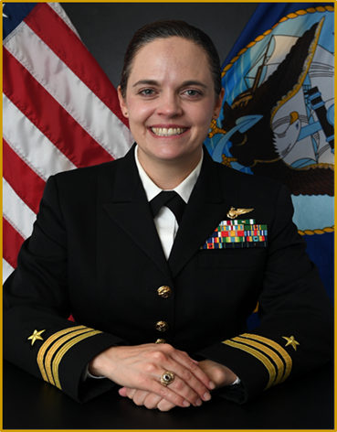

Commander Coffey is the prospective Commanding

Officer of Cooperative Security Location Comalapa,

El Salvador. CDR Coffey was raised in Dallas, TX.

She received her commission from the United States Naval

Academy in 2009 graduating with a Bachelor of Science in

International Relations and was designated a Naval Aviator

in 2011. She graduated from the United States Naval Test

Pilot School in Patuxent River, MD in 2016 earning her

Engineering Test Pilot qualification. She also earned a

Master of Arts in International Relations from American

Military University in 2017.

From 2012 to 2016, CDR Coffey completed her initial sea

tour with HSM-78 as part of Carrier Air Wing TWO

embarked on USS REAGAN (CVN 76), USS KIDD

(DDG 100), and USS MEYER (DDG 108). On her subsequent sea tour, she served as Department Head at HSM-77 from 2019 to 2022 as part of Carrier Air Wing FIVE embarked aboard USS ANTIETAM (CG 67) and USS REAGAN (CVN 76) in support of Department of State Enforcement Coordination Cell Operations and Battle Force SEVENTH and FIFTH Fleet operational missions including Operation FREEDOM SENTINEL and Operation ALLIES REFUGE. She served as the training officer, OIC of Combat Eleent ONE, and as the Maintenance Officer managing eight aircraft in the execution of 4,500 mishap-free flight hours.

CDR Coffey completed her first shore assignment at U.S. Naval Test Pilot School in 2016. As Project Officer at Rotary Wing Test and Evaluation Squadron TWO ONE from 2017 to 2019, she executed developmental test and evaluation for all U.S. Navy and Marine Corps rotary wing and tilt-rotor aircraft. She served as the lead Project Officer for 10 developmental test projects, including two MH-60 software upgrades, a $650 million ACAT II Electronic Attack airborne pod, and integrated ship-air testing with the Royal Australian Navy and the Spanish Armada Navy. During her tour at NORAD and USNORTHCOM, she served as an Action Officer in the J57 Branch supporting Strategy, Policy, and Plans for Counter Transnational Criminal Organizations from 2022-2023. While at NORAD & USNORTHCOM, she also was selected to serve as the Executive Officer to the Chief of Staff from 2023-2024 and the Executive Support Specialist to the Commander from 2024-2025.

CDR Coffey has flown over 2,000 mishap-free flight hours and has over 400 shipboard landings across 26 different aircraft. She is the recipient of the 2015 HSM-78 Pilot of the Year Award and the 2021 HSM-77 Officer of the Year Award. Her personal decorations include the Defense Meritorious Service Medal, Navy Commendation Medal (2 awards), the Navy and Marine Corps Achievement Medal, the Armed Forces Service Medal, and various other individual and unit commendations.